BINGN A APPRENTICE REFLECTIONS
By Maria Livet
It is a big thing to end something which has been lasting three intensive years, namely our biodynamic farming training and networking in the Nordic countries.
However, this journey into Anthroposophy and the Nordic nature and culture has worked so deep into me, I would proudly specify that these 3 years aren’t at all the end of a study, but more in its true self a start of a NEW era of a movement where I see the human itself has to take responsibility of its actions and create out of the mere consciousness it has, performing the best it ever can using all the resources which is given by mother earth and the universe.
That gives meaning for me to everything. If there is one sum-up of these three years together I would call it ‘organism’. Now, I know my place, I know the resources, I know the tools of finding the core of the question and I am capable of putting together all loose aspects to a thriving organism. I am so glad!!
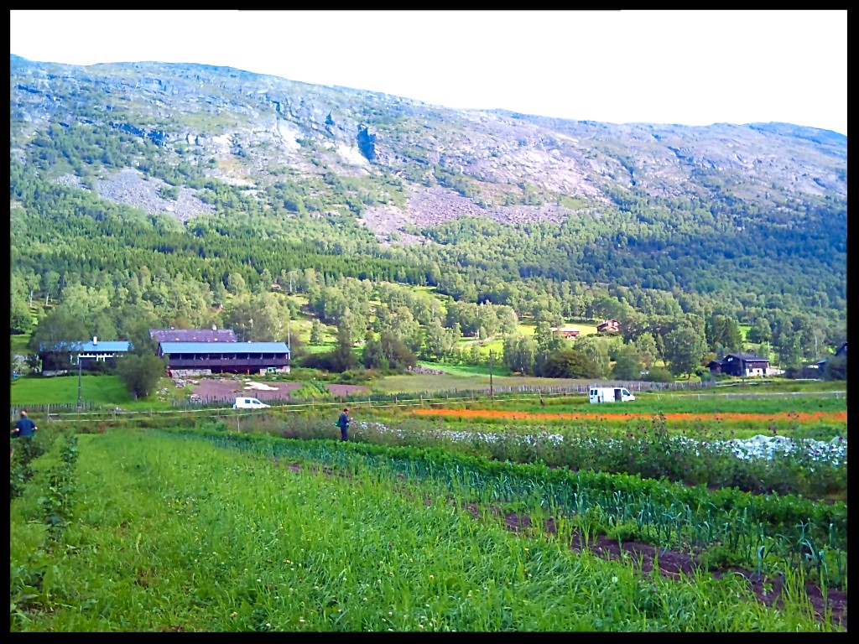
Photo from Aukrust gard og urteri, Lom, Norway
The networking of the Nordic countries; Finland, Sweden, Denmark and Norway, has given such an impulse which now shows its form of more communication between the farmers within each country and across borders. Bingn – Biodynamic Initiative for the New Generation Nordic – is now the actress of making the communication channels between all the different countries - despite language confusion and differences, despite the landscape and farming contraries’ with fjords and mountains to the sandy plains and to forest and lakes as far as your eye sight reaches (which isn’t too far in the Swedish forest).
Yes, it’s a rescue reaching out to the farmers of the North with their 60 plus years; ready and often desperate to hand their land over to the young, enthusiastic and knowledgeable.
The young doesn’t really wait for this; doesn’t actually know what farming is and the young really like to ‘wear white shoes’. In fact the young has not been taught very much about our food chain and the life of the farmer, but the one who do experience school gardens at young age get a fantastic foundation to life.
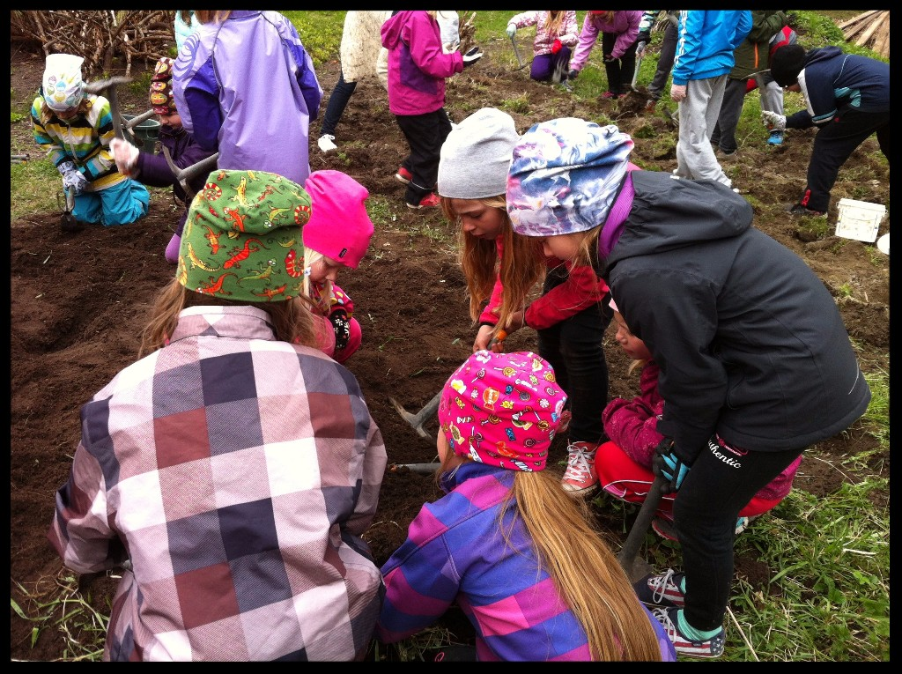
School kids digging a school garden at Labby Catering and garden, Isnäs, Finland
In my placement in Finland in my second year, I worked with school gardening and taught those kids the whole process from seed to seed. I experienced an incredible awe from the kids when they learned how much was edible, both of culture plants and wild plants. They got a different relationship with the nature and our daily food. They got so creative and inventive with the school garden I could just sit down in true awe.
Yes! The young farmer is out there and once she and he learns about it and how they can use their whole self in creating and engineering with mother earth, they will stream towards the land to create together.
From my perspective now, ‘Tomorrow’s farming’ is a social and smart way of farming; perhaps something like a fusion of biodynamics and permaculture.
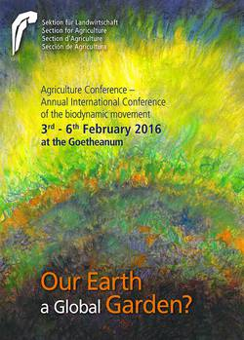
My first trip to the Goetheanum was during a Bingn ‘excursion seminar’ to central Europe; through Germany and ending at the agriculture conference, 2016. I joined the workshop about permaculture and biodynamics where we saw the similarities and differences of both. Many professors and teachers in biodynamics joined this workshop. Among them were the Swedish Agronomy PhD and Research Professor Artur Granstedt. He had seen the increase interest in permaculture and wanted now to understand more of what this is. It was a popular and redemptive workshop where the focus was on how permaculture and biodynamics can supplement each other, and about joining forces, instead of fighting each other. The reception was a success!
The stay at the Agriculture conference was great for us all Bingn’ers. When we left we wanted to come back!
Thanks to our honourable teacher and “father” of Bingn, Clemens Gabriel from Germany, we were lucky and honoured to experience in our last year of the Bingn training - a focus on mapping our future self; being a farmer and on the possibilities of developing a farm. It was a deep work into our self’s and made us gather all what we had learned and experienced in our life. This built up towards our last seminar which was going to consist of three important parts:
Visiting Clemens’ farm and celebrate his 28th birthday;
Going to Goetheanum, now for the second time, attending the theory U and anthroposophical based “Intensive study week” seminar where the goal would be to work on a burning issue;
Then the last instance, but far from least: Our Graduation as a biodynamic farmer in Järna, Sweden.
Oh, what a year!
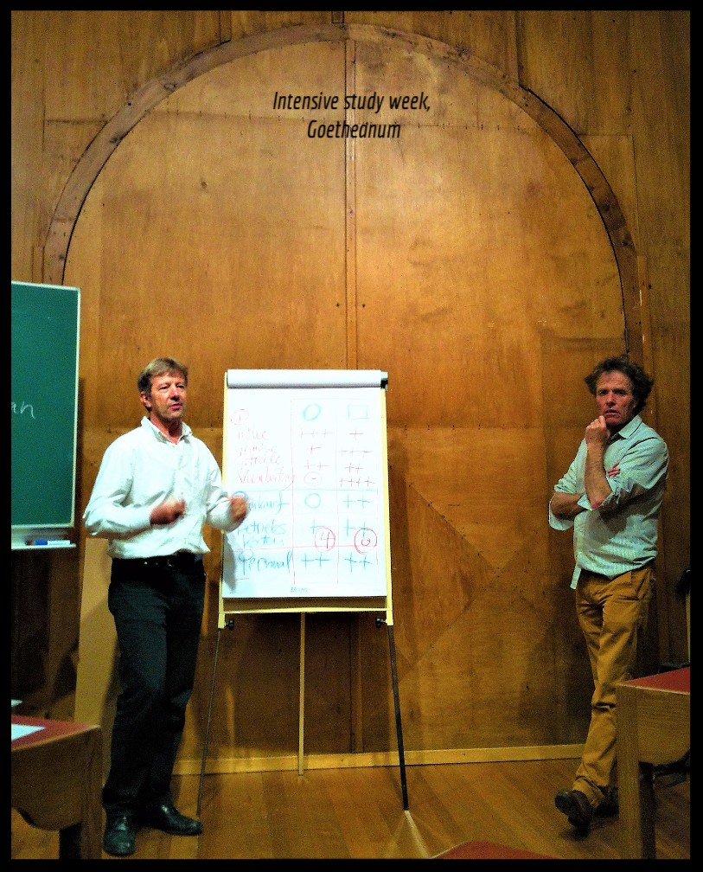
Meeting at Clemens’ farm was marvel and when celebrating him we all danced our three years of fruitful intensity together at the dancefloor in Marburgs best night club! It was the perfect start of the ending seminar.
As our group dynamics was flowering we sat off for the road trip to Donarch, far from knowing that this Intensive study week was going to clarify our status quo to an extent we hadn’t felt before. The seminar was led by Barbara Bäumler (eurythmist), Ursula Hofmann (gardener, adult educator and teacher in the biodynamic training of Switzerland), Ueli Hurter (co-leader of the Section for Agriculture at the Goetheanum, farmer at L'Aubier), Ambra Sedlmayr (researcher in agricultural sociology and environmental studies, personal counsellor) and Johannes Wirz (molecular and Goethean biologist, Natural Science Section, Goetheanum). We went along the U with Otto Scharmer and worked hard on our questions as well as listened to the calling of the future.
My question was about clarifying what my vision of life is. We helped each other with dialogue walks, questions and different group works. I got a tremendous amount of help. In the end of the U process we presented our prototypes! I had never talked nor presented anything of myself this clearly and strong before – what a milestone.
I can recommend it! It was an honour to join the study week and I want to give a great thanks to everyone who joined and organized.
With our beings in balance we travelled from Switzerland to Sweden, now heading for our last port; The Graduation. In the car we truly summed up our three years through this three day trip. We had come so far as a group organism that now we put everything on the table. We clarified and healed the beautiful bonds between each one of us!
Contemplating the three years we prepared for the last mentor talk and to formulate our final speeches and gifts for the graduation ceremony. Now we were going to show ourselves for friends, families and our network of amazing people in all the countries we had visited repeatedly.
As the first graduates of this kind at Skillebyholm, Järna, and in the whole of the Nordic countries, none of us had done this before.
In my last mentor talk I had the teacher Thomas Lüthi and the farmer Inge Schwagermann from Marcello’s farm who gave me 30 minutes to explain how I had performed in all the different aspects of these three years. I received so much compassion and a fantastic testament from them. Even gifts! I was totally amazed.
Then later the ceremony started and around 50 people gathered in Eken at Skillebyholm. Now the total Bingn founders and crew were gathered; the mother of Bingn - Laura Klemme, Elizabeth von Hanno Brockfield, Elizabeth Wirsching, Bingen father Clemens Gabriel and Ida-Johanna Carlander. This was the first time they were all gathered at the same time. In addition to them were students from the Bingn group C and the newcomers of group D - in an ocean of friends, family, farmers, teachers, people of the biodynamic movement and people of interest!
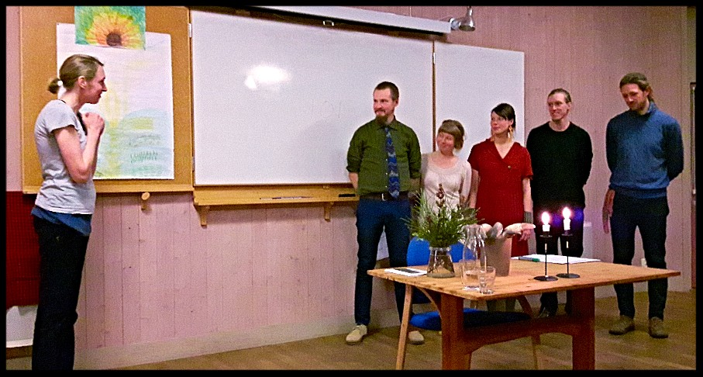
As us four, Matthew, Pernille, Oliver and I, held our speeches to all the attenders - people of our own and people who burn for the same - the feeling in the room was spectacularly warm with interest, gratitude, laughter, love and support. What an experience to life!
There were gratefulness and hugs, speeches, tears and laughter. It was a Graduation of us Bingn A’s, but there came also a reassignment speech from Clemens Grabriel as an organiser and keeper of Bingn. He has moved Bingn to what it is today with his menyfestly horsepowers of a different kind! He has digged the deep road tracks of the network in the Nordic countries. He has built up Bingn with attributes of all the elements. He has balanced Bingn with femininity and masculinity sweetly. He has been the one!
These countries will always lay soft on Nordic hay in his heart and he will be hired in as a teacher for future Bingn groups.
With the hangover form the glorious dinner made by Oskar Rosengren and Olivier Ton Frère Macer and the great party which had led into my 29th birthday; this whole arrangement really topped up with workshops led by the ‘Vår nye jord’ founder and BINGN graduate Pernille Vestskogen where people from our Nordic network had come to do work on the resources and possibilities of farmers and land as well as improving the Bingn structure.
The reverberations of Bingn’s work on visiting 105 biodynamic farms and ten of different related companies has strengthen communication and cooperation between the countries and within each country. Now, Vår nye jord, Bingn – Biodynamic Initiative for the New Generation Nordic and all the biodynamic association’s will continue to roll and create.
-And with us four graduates, Pernille Vestskogen, Oliver Schouw, Matthew Beasley and me, we will continue working as hosts and organizers of Bingn seminars and continue within farming in different ways.
Thank you all,
Maria Livet

